**Hospital Equipment Availability Checking Website**

**A Minor Project Synopsis Submitted to**



**Rajiv Gandhi Proudyogiki Vishwavidyalaya, Bhopal**

**Towards Partial Fulfillment for the Award of**

**Bachelor of Technology**

**(Computer Science and Engineering)**

**Submitted By**

**Ansh Joshi (0827CS201036)**

**Bhavik Mundra (0827CS201057)**

**Bhavik Sharma (0827CS201058)**

**Bhavika Darpe (0827CS201059)**

**Under the Supervision of**

**Prof. Ronak Jain**



**Department of Computer Science and Engineering**

**Acropolis Institute of Technology & Research, Indore**

**July-Dec 2022**

# Abstract

# There are currently only few websites available to inform individuals of the existence of open beds at a hospital. Most individuals are unaware of hospitals which have vacant beds and the requisite equipment. People check the availability by calling on the hospital number, available on internet. It is possible that the number offered is inaccurate, forcing them to endure great suffering before receiving the proper assistance they need.

To overcome this problem, we have come up with an idea of a web application which will inform and aware people regarding the vacancy of beds and availability of equipment in a particular hospital.

# Introduction of the Project

In this project, a web application will be created to get the information about the occupancy of beds and necessary equipments for the patients in a particular hospital, especially in emergency cases. An electronic system will be brought into usage to identify these and make patients aware and easy to find. The patients can easily find the location of desired hospital as well as the information about the number of empty beds present. The information will be kept updated which will result in building an efficient website.

# Objective

* The main objective of this project is to get the information about the availability of different types of beds in the hospitals of Indore.
* Additionally, this product provides information about the facilities provided by the hospital.
* The aim of this web application is to treat needs of hospitalized patients whose needs could be met outside a traditional hospital setting.

# Scope

The project’s scope includes all hospitals of Indore because there is presently no mechanism in place that can inform users about the hospital resources that are available. This system is heavily reliant on the data of any hospital that registers with the website and has to have their information updated.

# Study of Existing System

|  |  |  |  |  |
| --- | --- | --- | --- | --- |
| **S.No.** | **Existing System** | **Source** | **Strengths** | **Weaknesses** |
| 1. | Delhi Government Website | https://coronabeds.jantasamvad.org/ | Provides information about bed availability. | The information is not updated. |
| 2. | Bhopal | https://bhopalcovidbeds.in/ | Contains the list of government as well as private hospitals with contact no. available only. | It doesn’t show only the numbers of beds available in a particular hospital. |
| 3. | MP Government | http://sarthak.nhmmp.gov.in/covid/facility-bed-occupancy-dashboard/ | The information is kept updated. | The website doesn’t provide information about the facilities provided by the hospital. |

The website will provide information about the availability of beds and wards as well as various facilities available at a hospital.

# Project Description

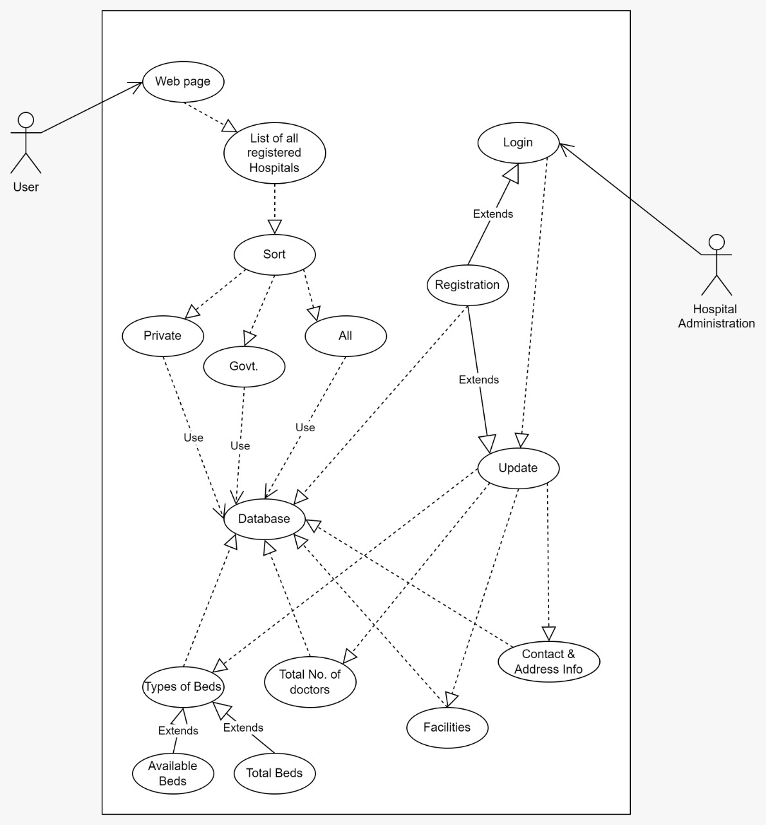

USE-CASE DIAGRAM

The project will be developed as follows and will contain the following

functionalities:

1. Login: This functionality is available for hospital administration only. A user cannot login as this website is made only for information sharing, user cannot book appointment from this website. Hospital administration first needs to register on the website.
2. Update: Hospital needs to keep the information updated time to time. When the information will be updated, it will immediately get reflected on the website.
3. Check availability of beds and facilities: The user may check the availability of beds and facilities at a certain hospital.

# Methodology/Planning of the Project work

1. We will be using HTML, CSS, JavaScript and Bootstrap to create frontend of the website. Python, Flask and MySQL will be used for backend. Flask-SQLAlchemy is a flask extension which will be used to provide tools and methods to interact with database in flask applications through SQLAlchemy.

2. First the hospital will register on our website through a registration form. The data from this form will be stored in our database by using flask- SQLAlchemy.

3. At the time of registration, we will ask hospital for password. The password should be of at least 8 digits and contain an uppercase character, a digit and a special character which will be verified by ‘javascript pattern’. Also, during registration, a verification code will be sent to verify email id using flask_mail API. This code will be entered on the registration page to verify the email provided.

4. The hospital will login into the account using the registered mail id and password. Here the password entered will be matched with the password stored in the database using flask.

5. If the password mismatches, then a method will be provided for password recovery. Hospital administrator can click on the forgot password link and provide the registered email address. An update password mail will be sent to the registered mail address and it will redirect to update password page. The update password page link will be sent using flask_mail API. Thereby changing password and applying captcha the password will be updated in database.

6. The necessary information regarding the bed and facilities will be displayed from our database using HTML, CSS, Bootstrap and flask for data interaction.

# Expected Outcome

An efficient and user-friendly website providing a facility for checking bed and hospital equipment availability. The database will be managed which will include the data as fed by the hospital administration. The outcome of this project will be a web application which will provide following facilities to the user:

* Search for a hospital
* Check bed availability
* Equipment and facilities available
* Location of hospital
* Contact information of hospitals

# Resources and Limitations

This website can run on any web browser. We will be using following languages for developing this website:

* HTML 5
* CSS 3
* JavaScript
* Python
* Bootstrap
* Flask, Flask-sqlAlchemy
* MySQL

The scope of the information which is available on website is limited to Indore city only. Moreover, the website majorly depends upon the data from different hospitals that will be registered with this system, which is the main limiting factor of this project. There can be difficulty in training hospital administration technically to use this system.

# Conclusion

The computerised system provides an efficient way to avail the facilities without consuming much time. It is easy for the users to keep track of empty beds as information will always remain updated.

# References

* 1. [**https://coronabeds.jantasamvad.org/**](https://coronabeds.jantasamvad.org/)
  2. [**https://getbootstrap.com/**](https://getbootstrap.com/)
  3. https://flask.palletsprojects.com/en/2.2.x/